7.7: As in Example 7.7, 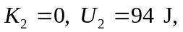 and 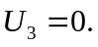 The work done by friction is

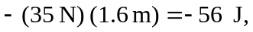 and so 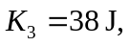 and 